DANSK HOVAWART KLUB FALL SHOW

SATURDAY THE 5th OF SEPTEMBER 2020

TIME: 10.00 A.M. (registration from 9.00 A.M.)

PLACE: Roskilde, Vikingeskibsmuseet

Vindebode 12, 4000 Roskilde

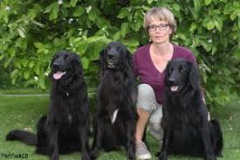

Judge: Annette Gund, Switzerland

Ring secretary: Lisbeth Holm Gundesen

Certificates for the title of: Danish Champion, Danish Junior and Veteran Champion as well as IHF-Champion
1. st. deadline for entry: The 1st of August 2020: 400,- DKK
2. nd. deadline: The 22th of August 2020: 500,- DKK

Entry via www.hundeweb.dk : Please go to “List of shows and closing dates – on-line entry” and follow instructions.
Please remember: There is no intermediate class at our show!
For more informations visit: www.dansk-hovawart-klub.dk
Questions about entry and the show to: udstilling@dansk-hovawart-klub.dk or cell phone +45 22670154 (Katharina Gaca, the Show Committee ).

